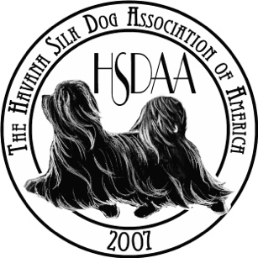

HSDAA “Doc” Joanne Baldwin Cardinal Award
Official Nomination Form

The standards for this award include:

- Outstanding Character | - Positive Role Model
- Impeccible Integrity | - True Sportsmanship
- Serves as an ambassador for the HSDAA and the Havana Silk Dog | - Optimistic Attitude

Nominee Name:

Nominating Member:

Nominating Member Contact Information:

Based on the standards listed above, why have you nominated the above person?

List qualities of this person, specific to those above, that emulate Doc Joanne Baldwin.

How has this person served as an ambassador for the HSDAA and the Havana Silk Dog?

Nominator Signature: ______________________________ Date: ________________

Note: The Award Committee must receive this application by July 5, 2026. This year’s nomination committee consists of the following former recipients of the Doc Baldwin Cardinal Award: Helen Conticchio, Mary O’Day, Marilyn Spence, Frank Conticchio, Henry Gunter, Linda Heimiller and Susan Ferguson.

Please remit your nomination to Mary O’Day (marymarthaoday@gmail.com).

