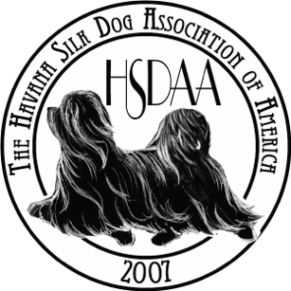

HSDAA “Doc” Joanne Baldwin Cardinal Award
Official Nomination Form

The standards for this award include:

- Outstanding character | - Positive role model
- Impeccable Integrity | - True Sportsman
- Serving as an ambassador for the HSDAA and the Havana Silk Dog | - Optimistic Attitude

Nominee Name:

Nominating Member:

Nominating Member Contact Information:

Based on the standards listed above, why have you nominated the above named?

List qualities of this person, specific to those above, that emulate Doc Joanne Baldwin.

How has this person served as an ambassador for the HSDAA and the Havana Silk Dog?

Nominee Signature: Date:

Note: The Award Committee must receive this application by September 15, 2021. This year’s nomination committee consists of Helen Conticchio, Mary O’Day and Marilyn Spence, all former recipients of the Doc Baldwin Cardinal Award.

Please send you Nomination to marymarthaoday@gmail.com

