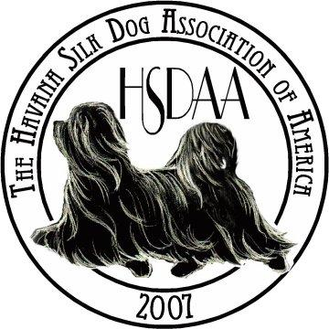

Havana Silk Dog Association National Specialty Show
Auction Donation Form

Name of Donor _________________________________________________________________

Donor Address _________________________________________________________________

City__________________________ State ________________ Zip ___________

Email _________________________ Phone ______________________

Item information

Item Name _________________________________________

Description of Item ______________________________________________________________

________________________________________________________________________________

Conditions/restrictions ___________________________________________________________

Market Value $________________

Delivery information

Send donation to

Havana Silk Dog Association of America
C/O Marilyn Spence, Show Events Coordinator
4417 Powells Point Rd
Virginia Beach, VA. 23455

If you have questions or need additional information, please call Janet Mulligan at 352-634-4391 or email janetmul@yahoo.com

